

**International Financial Management**

FIN-645

Section-1 (Summer 2021)

Foreign Direct Investment on Leather Industry in Bangladesh, by VF Corporation

Prepared for

**Dr. Tanvir Nabi Khan**

**Assistant Professor, Department of Finance, School of Business and Economics (SBE)**

**North South University**

Prepared by

|  |  |
| --- | --- |
| Name | ID |
| Yamundow Jah | 2016662660 |
| Arafat Ahmed | 2016224060 |
| Imdad Ur Rahman | 2016064060 |
| Nishat Tasnim Simu | 2016091660 |
| Sanjidul Karim | 2016296660 |
| Sazzad Mahmud | 2025359660 |

**Date of Submission: 20th September, 2021**

**Executive Summary**

VF Corporation is an American worldwide apparel and footwear company founded in 1899 and headquartered in Denver, Colorado. This corporation has selected Bangladesh because this country has huge potentiality and if we establish the manufacturing plant here we will be able to generate the positive cash flow quite soon. The key reasons of investing in Bangladesh are the availability of raw materials in low cost, cheap labor and ongoing demand of leather goods in whole Asia. That is why we are planning to invest huge amount of USD from our own financing. We have analyzed different risk analysis of this country and found that except political risk all other risks can be neutralized. For minimizing the political risk, we adopted various methods which are described in details. We have also analyzed the currency fluctuations of USD vs BDT in short term and long term and after that our findings for short term is encouraging. As Bangladesh bank is taking direct endeavor to keep the dollar exchange rate stable. For long term we have predicted that BDT may depreciate against the USD. To neutralize this currency risk, we adopted multiple hedging technique and as USA markets are quite strong in this aspect we believe that our hedging tools will be effective. Regarding multinational budgeting we have planned to finance USD 3,164,139 from our own source. After calculating the NPV we found out that within 3.45 year we will be able to see the payback period. At the end we also considered some likely scenarios of exchange fluctuation, uncertainty and counted the relative effect in the expected cash flows. As we have predicted a positive NPV within very short time thereby we believe that overcoming the financial barriers, international financial risks, volatility we will be successful in our venture.

Table of Contents

**1. Introduction** 4

**1.1 Overview of Leather Industry** 4

**1.2 Leather Industry in Bangladesh** 4

**1.3 Impact of Covid-19 on Leather Industry** 5

**1.4 About our Company** 6

**2. Rationale for Selecting Bangladesh and Leather Industry** 7

**2.1 Leather in Bangladesh** 7

**2.2 Global Exports of Leather Products of South Asian Countries** 7

**2.3 Steady Growth Trend of Livestock** 8

**2.4 Export Earnings from the Leather Sector** 9

**2.5 Growth rate of Leather Sector** 10

**2.6 Export of Processed Leather, Leather Footwear and Leather Goods** 10

**2.7 Country Wise Export Contribution of Leather Sector** 11

**2.8 Discussion about Amount of Investment** 12

**3. Country Risk Analysis** 13

**3.1 Financial Risk** 16

**3.2 Global Rating of Bangladesh** 18

**3.3 Credit Rating of Bangladesh** 22

**3.4 Political risk** 23

**4. An elaborate discussion on exchange rate impact on the project’s future cash flows** 26

**4.1 Historical analysis of the exchange rate** 26

**4.2 Forecasting Exchange rate** 26

**4.3 Interest Rate Parity (IRP)** 26

**4.4 International Fisher Effect** 28

**4.5 Purchase Power Parity** 28

**4.6 Derivative securities to manage exchange rate risk** 29

**4.7 Forward Market Hedge** 30

**4.8 Money Market Hedge** 30

**4.9 Option Market Hedge** 30

**4.10 Swap Contracts** 30

**4.11 Exposure to unfavorable exchange rates movements** 31

**4.12 Invoice currency** 31

**5. Multinational capital budgeting** 34

**5.1 Initial capital** 34

**5.2 Pro-forma Income Statement** 35

**5.3 Profitability insights** 41

**6. Conclusion** 42

**References** 43

# **1. Introduction**

### **1.1 Overview of Leather Industry**

The leather industry has been around for millennia, producing goods like leather footwear, leather bags, leather garments and so on. The raw materials for leather come from the waste products of the food industry, especially meat processing. Leather and the products of leather are one of the most globally traded goods, exceeding US$80 billion and predicted to rise in the coming years (Sivaram and Barik, 2019). The majority (65%) of global leather production come from bovine (cattle), 15% from sheep, 11% from pigs and 9% from goats. The areas of production depend heavily on where these animals are raised for food and wool. The majority of leather in the U.S and Europe come from China, India and Brazil and most of this leather is sourced from cattle. Countries like Australia and New Zealand account for the leather sourced from sheep, and Pakistan, Sudan and Bangladesh source their leather from goats and cattle. As a matter of fact, approximately 50% of all the leather produced today is expected to go into leather footwear, followed by furniture, clothing, leather goods, the automotive industry (parts in automobiles and aircrafts) and saddlery; all long-standing products of the global leather industry (The Global Leather Industry, 2021).

### **1.2 Leather Industry in Bangladesh**

In Bangladesh, the leather industry was developed on a large-scale, mainly in the 1970s, and it became the second largest export-earning industry, providing products like bags, shoes, garments, suitcases, jackets and belts, to both domestic and foreign markets. As of January 2019 Bangladesh meets about 10% of the world’s total demand of the leather market. About 85% of leather and leather products are exported to countries like U.S, Australia, Japan, Singapore South Korea and EU countries. There has been significant rise in investments of leather goods and footwear which, according to Mohammed Nazmul Hassan, the vice president of Leather Goods and Footwear Manufacturers’ and Exporters’ Association of Bangladesh ([LFMEAB](http://www.lfmeab.org/)), is partially due to the zero percent tariff rate at which Bangladesh exports footwear (Akter and Al Mahfuz, 2019). The other reasons include the cheap labor, domestic raw materials and high-quality service provided. In the last fiscal year, Bangladesh leather industry generated close to US$800 billion and leather footwear alone generated about US$480 million, more than 60 percent share of the leather industry.

Although China is the largest footwear manufacturer in the world, its share in the market has been on the decline and the ascension of its wages is not exactly helpful in a labour intensive industry such as leather and footwear. As a result of this and the attractive offers for FDI and joint ventures, Bangladesh’s competitive advantage is growing and it has been able to attract some key brands and shoemakers like Youngone, PICARD and others (Razzaque et al, 2018).

### **1.3 Impact of Covid-19 on Leather Industry**

“The Covid-19 pandemic is the characterizing worldwide wellbeing emergency within recent memory and the best we have looked at since World War Two” according to UNDP. The virus has spread to all continents with cases rising every day and nations rushing to slow the spread of the virus but with no permanent prevention in the horizon yet. However, the Covid-19 is more than just a wellbeing emergency, as due to its worldwide spread it has affected the social, financial and political wellbeing of nations around the world. The story of Bangladesh leather industry during this outbreak is full of despair and challenges as the industry faced millions of dollars’ worth of order cancellations (Khan, 2021). As Bangladesh imports its raw materials for hide processing from China, Bangladesh’s leather footwear and goods became crippled early 2020 due to lock down in China. There were cancellations of leather goods and footwear, worth $250 million, from the exporters. And due to lock down, the industry could not cash in on about Tk. 1000 crore of local demand during the Eid ul Fitr. As a result, the leather industry had a 21% decline in overall revenue, from US$1.019 billion in 2019 to US$798 million in 2020 (LightCastle Analytics Wing, 2020). Due to credit crunches, the sector has had to rely on government support to help them through this period. However, as lock downs eased and factories opened in May the industry experienced spikes in exports. Unfortunately, in the fiscal year of 2021, in July- September period, there was a 22.45% decline in shipments, leather goods dropped by 4.15% but the leather footwear increased by 0.2%. Moreover, buyers have started to take back cancelled orders as international retailers and brands reopen their doors. And according to the Leather goods and Footwear Manufacturers and Exporters Association of Bangladesh, the leather industry could fetch up to US$ 5 billion in export receipts if the 165 approximate footwear and leather factories in Bangladesh were compliant to the use of modern technology (Khan, 2021).

### **VF Corporation Announces Regional Transformation Plan to Enable Long-term Growth in Asia1.4 About our Company**

VF Corporations is one the largest apparel, footwear and accessories companies who have been in business for 120 years, connecting consumers around the world to desired activities, lifestyles and experiences. It is a billion-dollar American company that has about 12 different brands, including Timberland, Eastpak, The Northface, Kipling, Vans and others. All these brands are connected through global business platforms, central resources and strategic investments that allow them to flourish. The Timberland brand has been in existence since 1968. Their product innovations began with waterproof leather boots and since then they have introduced different other innovations like the boat shoes, hand-sewn casual shoes with premium leather, Timberland apparel and others. Since the invention of the original waterproof boots, the focus has been on inventing environmentally-conscious outdoor products with high durability. The Eastpak brand was founded in 1952, in Boston, America. They specialize in manufacturing and producing products like bags, backpacks, accessories and travel gear. It was the first brand to produce wheeled luggage and the first brand to offer a lifetime warranty on its products.

Just like all other businesses VF Corporation was impacted negatively by the Covid-19 pandemic and ended up with a global revenue of US$9.2 billion in fiscal year 2021, a 12% decrease from the previous year. The earnings per share dropped by 42%, at $0.91 from $1.57 in 2020. As a global company, VF Corporations faces financial risks like exchange rate exposure, capital market disruptions or securities markets volatility. The company, of course tries to mitigate some of these risks like the exchange rate exposure risks. Although no hedging strategy can completely insulate all foreign exchange risks, VF Corporations do employ a hedging strategy for a good portion of its foreign currency transaction exposures that arise in the ordinary course of business, to reduce risks in cash flows and earnings.

# **2. Rationale for Selecting Bangladesh and Leather Industry**

Since 1970s, the leather industry has been developing on a large scale. Moreover, this industry currently worth around $1.90 billion with 40% of the total demand being met from imports. Bangladesh government also deem the leather goods and footwear as one of the main growth generators for the country. This leather industry of Bangladesh also meets the demand for about 10% of the world’s total leather market. In addition, Bangladesh leather industry produces leather based products like shoes, bags, jackets, belts etc. Not only these, there are several considerations by which we can justify our choice of country and industry which are discussed below:

### **2.1 Leather in Bangladesh**

In Bangladesh, leather industry is the oldest industry and plays a significant role in the national economy with goodwill in world. This industry is agro based by product industry with available local indigenous raw materials with great potentiality for export development and sustained growth over upcoming years. There are several attributes which are the reason of widely known of Bangladesh leather around the world. These are, uniform fiber structure, high qualities of fine grain, natural texture and smooth feel.

### **2.2 Global Exports of Leather Products of South Asian Countries**

If we see in the figure, global exports of leather products of Bangladesh is increasing year by year. Though it is not sufficient comparing with other south Asian countries, like India, Pakistan and Sri Lanka, but we decided to invest in Bangladesh because, there will be a good opportunity for us to utilize our global expertise and goodwill in this leather industry to minimize this global exports of leather products gap with other pioneer South Asian countries. Data from 2013-2010 also indicates that, not all the opportunity are utilized or exploited by existing leather goods supplier in Bangladesh, therefore we decided to apply our expertise in this Bangladeshi leather industry.

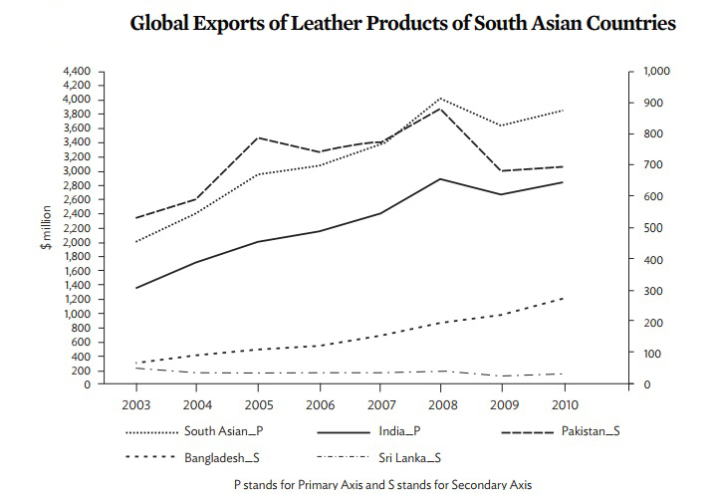

**Source:** United Nation’s Commodity Trade Statistics Database (COMTRADE), based on HS 2002 classification. comtrade.un.org/db/

### **2.3 Steady Growth Trend of Livestock**

The rawhide of leather product are collected from livestock. Bangladesh manufactures leather of 220 million sq.ft. (Approx.) comprising of 63.98% cowhides, 32.74o% goat skins, 1.09% sheepskins and 2.19% buffalo hides. Leather and leather goods exported from Bangladesh are in the form of blue wet leather, leather garments, crushed leather, finished leather and footwear. In addition with, the livestock population is shown a steady growth which implies Bangladesh has sufficient rawhides to support upward production of leather and leather goods.  
  
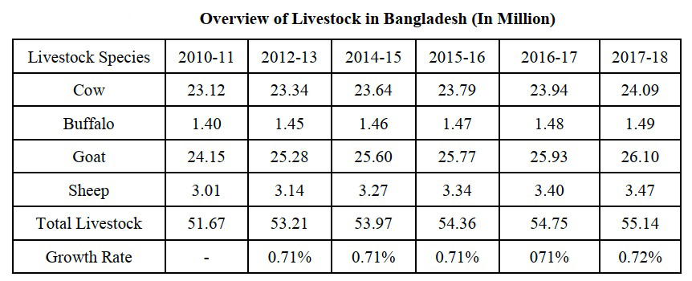

**Source:** Department of Livestock Services (2018)

### **2.4 Export Earnings from the Leather Sector**

In Bangladeshi export earning sector, leather industry holds the second position. Moreover, Bangladeshi export has seen an excellent growth of leather sector over the years. Leather, leather products, and leather footwear items exports climbed from $137 million in 1990-91 to $462.88 million in FY2007-08, accounting for about 3.3 percent of overall export revenues, indicating a trend growth rate of 11.6 percent. From following figure we can see that, In FY1990-91, the leather sector contributed 8.14 percent of the country's export share, worth 137 million dollars. It has gradually grown its contribution to export earnings since then.   
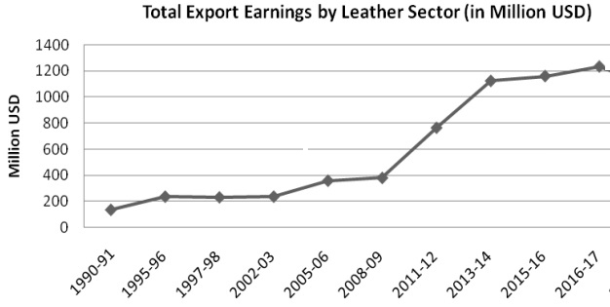

**Source:** Export Promotion Bureau’s Statistical Yearbook (2019)

### **2.5 Growth rate of Leather Sector**

Because of the global recession, the export growth rate of Bangladesh's leather business was initially negative from 2001 to 2002. Following that period, the growth rate began to accelerate, peaking at 15.46 percent in 2006-2007, as demand for high-quality raw materials for completed leather items grew in developed countries. The export growth rate is presently rebounding due to global market demand for Bangladesh leather and leather goods, as shown in the graph. Compared to the single-digit rise in export revenues throughout the 1990s, the industry has grown at a fantastic pace of over 20% since 2009-10, and it has recently surpassed a billion dollars in exports.

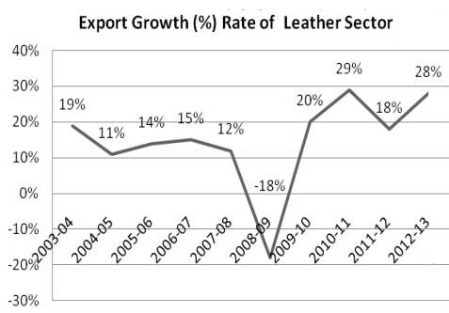

**Source:** Export Promotion Bureau’s Statistical Yearbook (2019)

### **2.6 Export of Processed Leather, Leather Footwear and Leather Goods**

Almost all of Bangladesh's leather products are destined for export, with the bulk being crushed leather, finished leather, leather products, and leather footwear. In terms of revenue, these products accounted for around 2.52 percent of total leather industry exports from Bangladesh in FY 2018-19, totaling 1019.78 million USD. Processed leather, leather footwear, and leather goods contributed 459.25 million USD in FY 2009-10, with processed leather contributing for USD 226.1 million, leather products contributing for USD 29.06 million, and leather footwear contributing for USD 204.09 million. The leather sector earned a peak amount of $1233.99 million in FY 2016-17, and leather items were the highest amount in export performance ($464.43 million) in this financial year. Moreover, leather footwear has been steadily expanding since 2015-2016, with export earnings of $607.88 million in FY2018-2019, up from $565.6 million in FY2017-18.

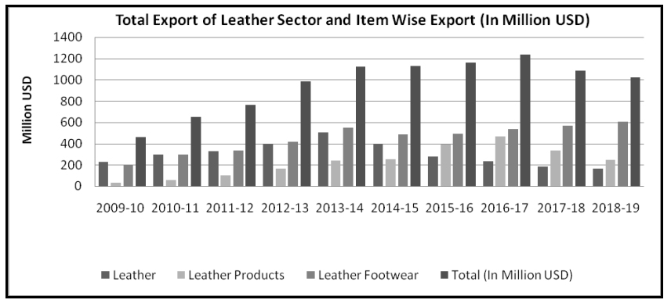**Source:** Export Promotion Bureau’s Statistical Yearbook (2019)

### **2.7 Country Wise Export Contribution of Leather Sector**

Bangladesh exports processed leather, leather products, and footwear to roughly 53 nations around the world. Approximately 95% of Bangladesh's leather exports are largely in the form of crushed leather, blue wet leather, finished leather, leather garments, and footwear. In Asia, Bangladeshi leather industry holds fourth position. Most leather and leather goods export to Germany, Italy, France, the UK, Belgium Netherlands, Spain, Russia, Brazil, China, Singapore France, Germany, Poland, the US, Canada, and Taiwan are the prominent markets for Bangladeshi leather industry. However, Bangladeshi finished leather is mostly imported by Hong Kong, China, and Italy for use in the manufacture of leather goods and footwear in their respective industries. The majority of Bangladesh's leather items are exported to the United States and Japan. The bar graphs show that overall export volume to the United States in FY 2018-19 was 207.14 million USD, up from 33.49 million in FY 2012-13, a nearly 174 million increase.

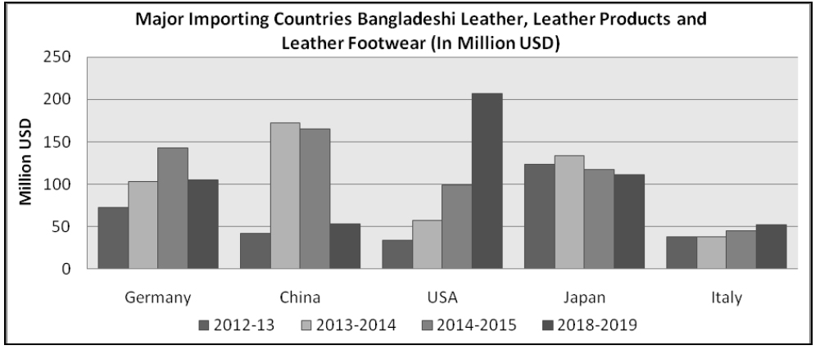

**Source:** Export Promotion Bureau’s Statistical Yearbook (2019)

### **2.8 Discussion about Amount of Investment**

Our initial investment is BDT269, 600,000.00 or USD 3,164,319.25. In order to estimate our initial investment, we used financial information from top leather goods manufacturer of Bangladesh named as Apex Tannery Limited and Bata Bangladesh. The use of those financial information as benchmark and based on this benchmark process of estimating our amount of initial investment discussion is given below:

In year 2019, revenue of Bata and Apex are BDT 8,573,497,561 and BDT 2,041,083,000. They are the pioneer in this leather industry. As we are going to invest and start as a new company it will not possible for us to earn revenue like them. So, in first year we estimated our revenue as BDT 215,000,000 based on asset turnover ratio of those companies. The details are given in capital budgeting section.

Bata and Apex’s property, plant and equipment amount in 2019 are eventually BDT 1,103,116,021 and BDT 1,154,384,000. If I consider the revenue as benchmark those property, plant and equipment are 12.87% of Bata revenue and 56.56% of Apex’s revenue. As we are new comer we estimated our property, plant and equipment amount isBDT152,800,000 which is 71.07% of our first year estimated revenue. This amount included the cost of land, factory building, plant and machinery, office equipment, furniture and fixture, motor vehicles. The percentage is higher than Bata and Apex because we have to purchase those property, plant and equipment to setup our new operation. Gradually, in future there will be subtler balance of this percentage comparing with beginning year.

In addition Bata and Apex’s administration, selling, distribution and operating expenses are BDT 2,785,623,693 and BDT 163,860,000. Again considering their revenue as benchmark those expenses are 32.49% of Bata revenue and 8.03% of Apex’s revenue. Our estimated administration, selling, distribution and operating expenses is BDT 116,800,000 which is 54.33% of our first year estimated revenue. This amount included the cost of company formation and registration, legal and other consultation fees, promotional expenses, initial working capital, initial HR expenses.

The detail financial statements of Bata and Apex are provided in appendix section of this report for further future analysis and estimation.

# **3. Country Risk Analysis**

A country risk assessment can help a business identify and evaluate country-specific risks. In doing so, businesses can determine how much those risks might impact their business and what steps they can take to manage or mitigate those risks. The importance of this type of country risk analysis cannot be overstated. Without it, businesses could face unexpected and potentially devastating [changes to the business environment](https://www.eulerhermes.com/en_US/insights/challenges-current-business-environment.html) without warning.

* Country-specific risks cover a wide spectrum. When a potential investor is ready to explore international investments, he/she can conduct country risk analysis via qualitative and quantitative assessments, or a combination of both. Quantitative analysis uses an objective analysis of ratios and statistics to determine risks. These assessments may include the debt-to-gross domestic product ratio or the beta coefficient of the Morgan Stanley Capital International (MSCI) index for a country. Qualitative analysis determines risk based on subjective analysis of things like political news and market rumors
* The MSCI Frontier Markets Index captures large and mid-cap representation across 27 Frontier Markets (FM) countries. The index includes 81 constituents, covering about 85% of the free float-adjusted market capitalization in each country (MSCI, 2021)

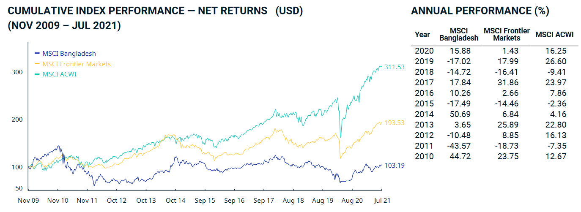Source: (MSCI, 2021)

If we analyze the MSI index of Bangladesh, then we will be able to see that during global financial crisis our MSI index was uprising but after the financial crisis when whole world’s economy has been growing with an uprising trend our economy is still struggling to compete with the rest of the world. Whereas the Fortier market index is still pretty high than us.

Frontier markets represent "the next wave" of investment destinations. These markets are generally either smaller than traditional emerging markets or are found in countries that place restrictions on the ability of foreigners to invest. Although [frontier markets](https://www.investopedia.com/terms/f/frontier-market.asp) can be exceptionally risky and often suffer from low [liquidity](https://www.investopedia.com/terms/l/liquidity.asp), they also offer the potential for above-average returns over time. Frontier markets are also not well correlated with other more traditional investment destinations, which means that they provide additional [diversification](https://www.investopedia.com/terms/d/diversification.asp) benefits when held in a well-rounded investment portfolio. As with emerging markets, investors in frontier markets must pay careful attention to the political environment, as well as to economic and financial developments. Examples of frontier markets include Nigeria, Botswana, and Kuwait.

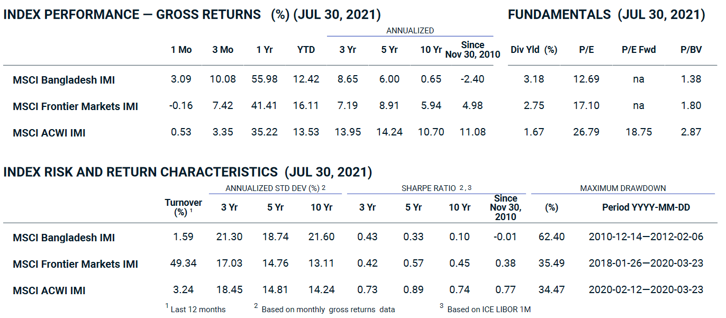Source: (MSCI, 2021)

In the Index performances of Gross return as on 30 Jul 2021, Bangladesh’s MSCI IMI is pretty low comparing to MSCI frontier and MSCI ACWI. The main reason is the due to global pandemic this country has not recovered the economic shocked it received. On the other hand, if we look in the Index risk and return characteristics the 10 year annualized standard deviation is pretty high than other indexes. Similarly, the Sharpe ratio changed 62.40 percent whereas the other index changed only 35% approximately.

In the MSCI global market accessibility review as of June 2020, Bangladesh has received rating of ++ (which indicates no issues) in the openness to foreign ownership and also Market organization (which includes market regulations and information flow) (MSCI, 2020).

**3.1 Financial Risk**

|  |  |  |  |  |
| --- | --- | --- | --- | --- |
| Topic | 2017 | 2018 | 2019 | 2020 |
| Real GDP Value | |  |  | | --- | --- | |  | 179,992,118,771 | | 194,146,236,466 | 209,974,367,461 | 214,962,354,032 |
| GDP growth (%) | 7.284 | 7.864 | 8.153 | 2.377 |
| Inflation (yearly average, %) | 5.70 | 5.54 | 5.59 | 5.69 |
| Budget balance * (% GDP) | -3.34 | -4.64 | -5.43 | -5.47 |
| Current account balance (% GDP) | -.917 | -3.745 | -1.366 | -1.611 |
| Public debt (% GDP) | 33.38 | 34.57 | 35.69 | 38.86 |

Among South Asian economies, Bangladesh is touted as a rising star. In 2019, its per capita income was $1,856—substantially higher than Pakistan’s $1,285 and only $250 less than that of India. In 2020, Bangladesh might have edged ahead of India because it registered a growth rate of 2.4 percent whereas India’s GDP shrank by 7.3 percent. These numbers—especially the positive rate of growth during the pandemic year—are striking, part of an impressive growth performance that has averaged close to 6 percent per annum since the turn of the century. Few least developed countries can match Bangladesh’s record in this respect. Various indicators of human development also show significant improvement: life expectancy in 2019 was 72.6 years, a gain of over 7 years since 2000; mean years of schooling were up from 4.1 to 6.2; and the country’s human development index (HDI) value had climbed from 0.478 in 2000 to 0.632 in 2019. Bangladesh’s HDI ranking is now 133rd out of a total of 189 countries, still relatively low but better than both Pakistan (154) and Nepal (142).

Currently, Bangladesh is considered as a developing economy. Yet, almost one-third of Bangladesh’s 150m people live in extreme poverty. In the last decade, the country has recorded GDP growth rates above 5 percent due to development of microcredit and garment industry. Although three fifths of Bangladeshis are employed in the agriculture sector, three quarters of exports revenues come from producing ready-made garments. The biggest obstacles to sustainable development in Bangladesh are overpopulation, poor infrastructure, corruption, political instability and a slow implementation of economic reforms.

The annual inflation rate in Bangladesh eased to 5.02 percent in January of 2021 from 5.29 percent in the previous month. It was the lowest inflation rate since September of 2012, amid a slowdown in prices of food (5.23 percent vs 5.34 percent in December) and in non-food products (4.69 percent vs 5.21 percent). On a monthly basis, consumer prices increased 0.91 percent, after falling 0.45 percent in the previous month A moderate inflation rate is quite important for a FDI has investor look to expect profit from future inflation rate after investment.

Generally, Government debt as a percent of GDP is used by investors to measure a country ability to make future payments on its debt, thus affecting the country borrowing costs and government bond yields. In 2020, government debt (% of GDP) for Bangladesh was 38.9 %. Government debt of Bangladesh fell gradually from 42.3 % in 2006 to 38.9 % in 2020.

Bangladesh's economy is anticipated to go through a collapse in the current fiscal year due to the Covid-19 outbreak. The economy will take long time to fully recover. Thereby, to overcome from this situation our Bangladesh government need to take expansionary fiscal policy but slowly. An expansionary fiscal policy will increase the public debt which may in turn discourage the investors to invest. Again on another note it is a positive sign as government is taking measures to recover the economy so the support from the government will continue.

Regardless of the high economic growth of 8.1% prior to the pandemic, Bangladesh has struggled to attract foreign direct investments (FDI) into the country which can be explained by the low FDI to GDP ratio of 0.5% in 2019 (Light Castles Analytical Wing, October 8, 2020). Infrastructural challenges and gap in policy implementation are some of the primary reasons.

Naturally, the yearlong pandemic has slowed down the global flows of FDIs. The World Investment Report 2020 by the United Nations Conference on Trade and Development (UNCTAD) has predicted a 40% percent decline in FDI flows in 2020. Nonetheless, the numbers can be expected to be stable in 2021, with the recovery of economies.

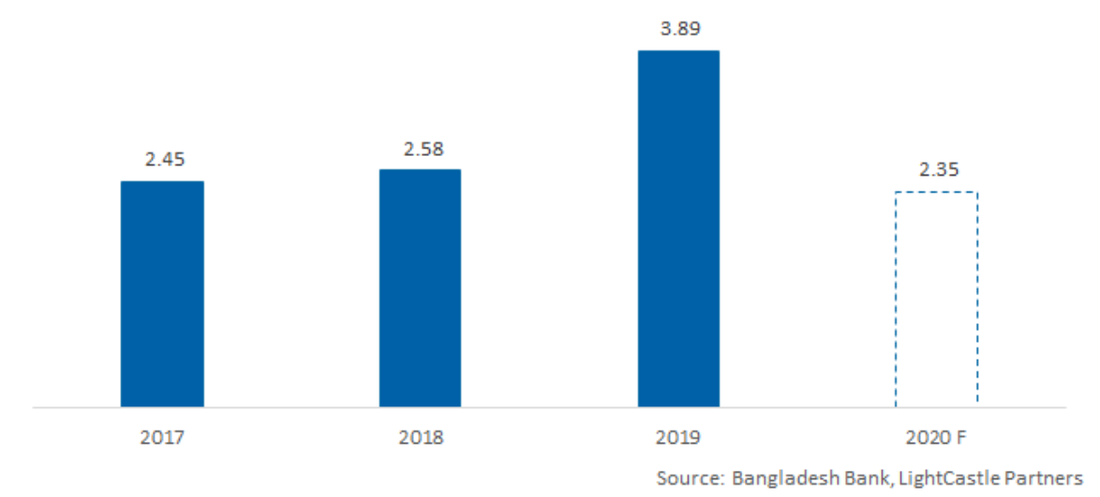  
**FIGURE:** Total FDI inflows (net) between 2017 to 2020 (July-June) / Source: Bangladesh Bank

### **3.2 Global Rating of Bangladesh**

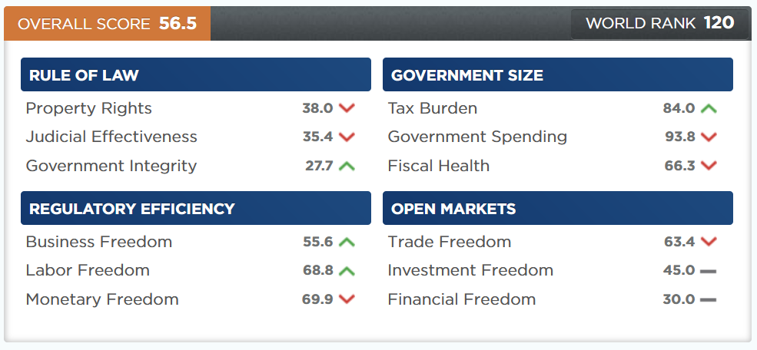

**Figure:** Bangladesh’s economic freedom score (The Heritage Foundation, 2021)

Bangladesh’s economic freedom score is 56.5, making its economy the 120th freest in the 2021 Index. Its overall score has increased by 0.1 point, primarily because of an improvement in the tax burden score. Bangladesh is ranked 25th among 40 countries in the Asia–Pacific region, and its overall score is below the regional and world averages.

Bangladesh has made slow but steady progress toward greater economic freedom over the past decade. While the economy remains in the mostly unfree category, the control of government spending and debt has been a positive achievement. Additional improvements in judicial effectiveness and government integrity would strengthen the rule of law, and opening the banking sector to foreign competition would further benefit the country.

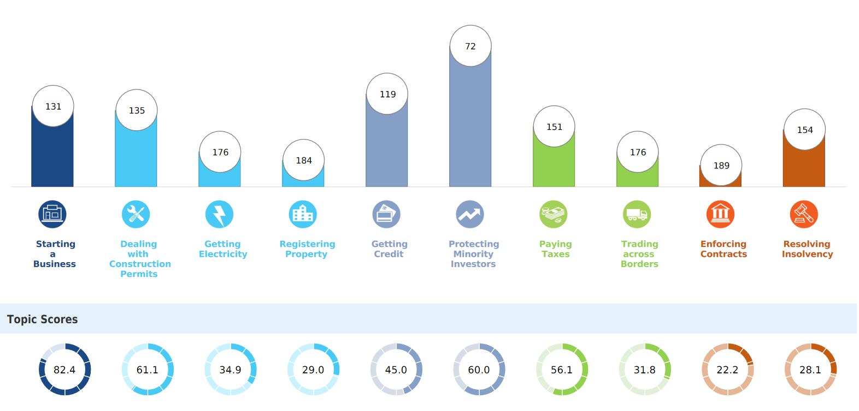

**Figure:** Rankings of Doing Business Topics in Bangladesh (World Bank Group, 2020)

Every year, the World Bank (WB) creates a list of 190 countries based on business environment metrics.

In their last index, Bangladesh ranked 168th out of 190 in 2020. In a recent webinar, Bangladesh Investment Development Authority (BIDA) Executive Chairman Sirajul Islam commented that by 2021, they projected Bangladesh to improve its position to 99th.

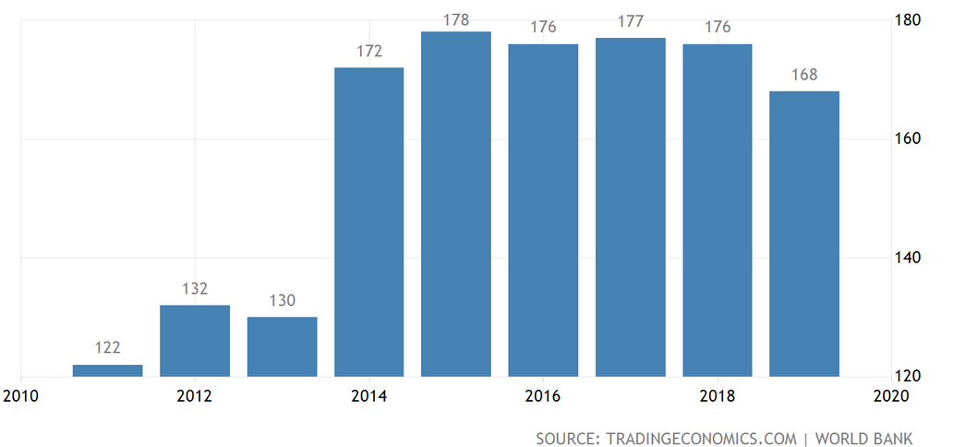

**Figure: Ease of Doing Business in Bangladesh**

The Ease of doing business index ranks countries against each other based on how the regulatory environment is conducive to business operation stronger protections of property rights. Economies with a high rank (1 to 20) have simpler and friendlier regulations for businesses.

Bangladesh advanced 8 notches in global ease of doing business ranking to 168 out of 190 counties, according to a report of World Bank. The country rose to the rank of the 168th from 176th in the previous year, the WB said in its Doing Business 2020. The jump was aided by the country’s improved score in the areas of starting a business, dealing with construction permits, getting electricity, registering property, and getting credit.

The Doing Business Report (DB) is an annually published report which was developed by a team led by Djankov in 2003. It has been elaborated by the World Bank Group since 2003 every year that is aimed to measure the costs to firms of business regulations in 190 countries. The study has become one of the flagship knowledge products of the World Bank Group in the field of private sector development and is claimed to have motivated the design of several regulatory reforms in developing countries. The study presents every year a detailed analysis of costs, requirements, and procedures a specific type of private firm is subject in all countries, and then,

creates rankings for every country. The study is also backed up by broad communication efforts, and by creating rankings, the study spotlights countries and leaders that are promoting reforms.

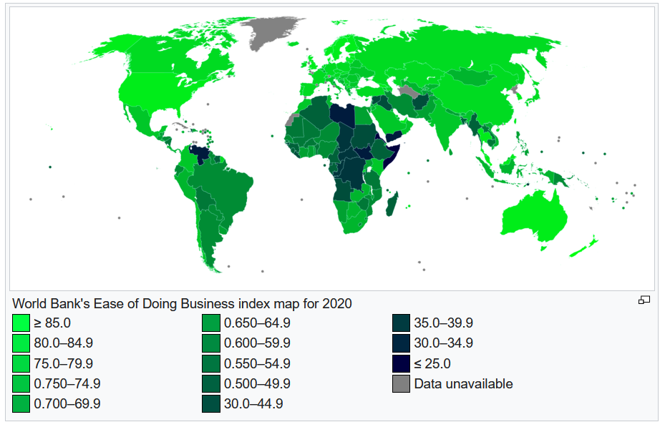

India, in 77th place in the Doing Business rankings, is the highest ranked economy in South Asia, followed by Bhutan (81) and Sri Lanka (100). The region’s lowest ranked economies are Afghanistan (167) and Bangladesh (176). Other economies in the region and their rankings are Nepal (110), the Maldives (139), and Pakistan (136).

### **3.3 Credit Rating of Bangladesh**

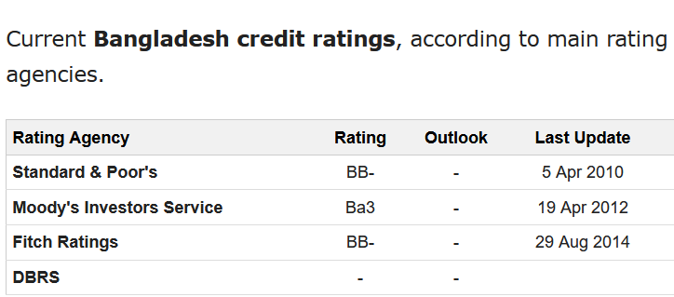

Standard & Poor's credit rating for Bangladesh stands at BB- with stable outlook, while Moody's credit rating for Bangladesh was last set at Ba3 with stable outlook in April 2012 and Fitch's credit rating for Bangladesh was last reported at BB- with stable outlook in Aug 2014.

A sovereign credit rating is an independent assessment of the [creditworthiness](https://www.investopedia.com/terms/c/credit-worthiness.asp) of a country or sovereign entity. Sovereign credit ratings can give investors insights into the level of risk associated with investing in the debt of a particular country, including any [political risk](https://www.investopedia.com/terms/p/politicalrisk.asp). At the request of the country, a [credit rating agency](https://www.investopedia.com/articles/bonds/09/history-credit-rating-agencies.asp) will evaluate its economic and political environment to assign it a rating. Obtaining a good sovereign credit rating is usually essential for developing countries that want access to funding in international bond markets.

The steady position of Bangladesh reflects composed risks. Active implementation of economic recovery measures to enlarge Bangladesh's slim return base and appeal DFI could raise government profit income beyond the anticipated flow. In addition to that, a quickening implementation of all types of economic factor will create the base of future foundation of infrastructure, rules, policy, human capital and people’s mindset in all sector. On the contrary, feebler execution of actions to enlarge Bangladesh's slim income base and complementary economic and fiscal modifications would gradually compel the government's fiscal plasticity.

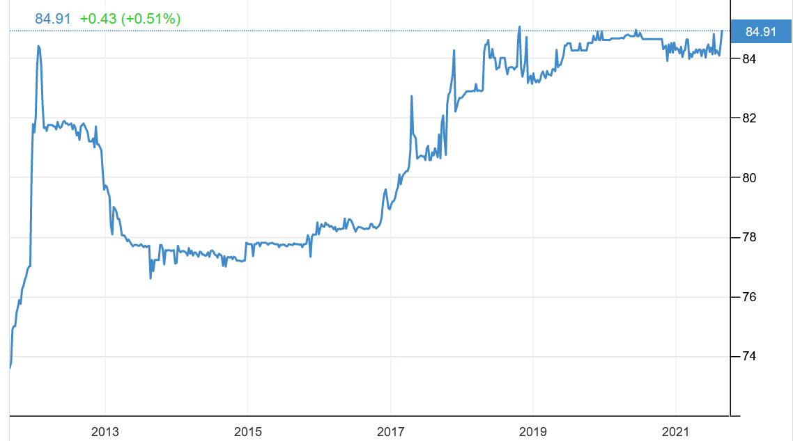

**Figure**: The USD vs BDT rate fluctuation of last 10 years.

If we analyze the above graph we will be able to see that since 2019 the rate has gradually stable keeping the hope of FDI more luminous.

### **3.4 Political risk**

Bangladesh has recorded 4 index point in 2019 in the Medium/long-term political risk (1=low, 7=high) indicator. The medium-/long-term political risk classification measures the probability of a risk caused by governmental and integrated events connected to cross-border transactions with a risk prospect beyond 1 year. Thereby the Political risk in Bangladesh can be considered to be moderate to high.

Formerly East Pakistan, Bangladesh only came into being as a separate country in 1971, when the two parts of Pakistan split after a bitter civil war. Bangladesh spent 15 years under military rule, with democracy restored in 1990. The Bangladesh National Party and Awami League alternated in power between 1991 and 2013, with the exception of a military-backed, emergency caretaker regime that suspended parliamentary elections planned for January 2007 in an effort to reform the political system and root out corruption. That government returned the country to fully democratic rule in December 2008 with the election of the AL and Prime Minister Sheikh HASINA. In January 2014, the incumbent AL won the national election by an overwhelming majority after the BNP boycotted, extending HASINA’s term as prime minister. On 30 December 2018 again a election took place and BAL achieved landslide victory in that election. This country is mostly dominated by a single party who remains in the power and the likelihood of next election is on 2023. With the help of international development assistance, Bangladesh has made great progress in food security since independence, and the economy has grown at an average of about 6 percent over the last two decades

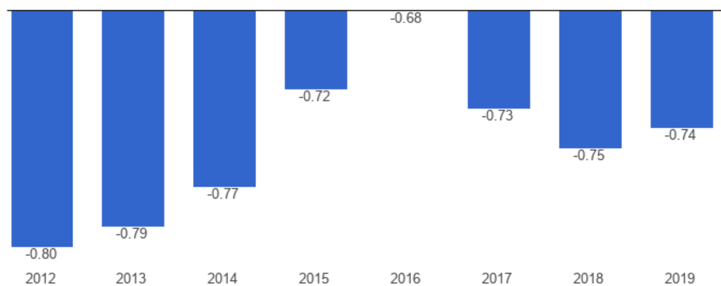

**Figure**: Bangladesh: Government effectiveness index (-2.5 weak; 2.5 strong), 1996 – 2019

Recently the political situation has shown some symbols of steadiness, though there is a huge potential for religious based violence. There are other factors which are also related to political risks.

Currently the Rohingya Refugee crisis is one of the major political risks of this country. Due to ethnic terrorism in Myanmar a lot of Muslim people fled away from Yangon and other places and they are staying in Cox’s bazar. The total number of this type of people is more than 1.2 million. Due to this influx of lot of unskilled migrants Government are facing difficulties both in national and international level.

The low inflow of FDI in Bangladesh indicates the need for reforms in policies and regulations to restructure the business environment and earn investors’ confidence. This is echoed by Nomura, a Japanese financial services firm, which reported that Bangladesh was not chosen by any of the 51 companies who relocated their production out of China between 2018 and 2019. To increase foreign direct investments in the country, Bangladesh must provide solutions to several overarching problems that lie in the path. The challenges can be classified into two segments; short-term challenges that immediate attention can unravel and long-term ones that necessitate comprehensive policies and proper implementation to be resolved

One of the key impediment of Bangladesh for FDI is corruption and political violence. Most of the government agencies are claimed to divulge in bribes and illegal utilization of government resources. Lack of political stability needs to improve in order to encourage FDI from all over the world

# **4. An elaborate discussion on exchange rate impact on the project’s future cash flows**

### **4.1 Historical analysis of the exchange rate**

The historical trend of BDT/$ exchange rate shows that the fluctuation is quite inconsequential and almost been in a steady position from 2019, with a variance of 4.11 and standard deviation of 2.03 in terms of the changes in BDT/$ in the last 5 years. Although slight changes may incur huge losses considering the volume of currencies to be exchanged. The graph shows a slightly upward trend in the long run with no major short term fluctuation in the immediate years.

### **4.2 Forecasting Exchange rate**

Since being an MNC, VF Corporation has to deal with multiple currencies and denominate the returns to the home currency in the end, the impact of exchange rate movement plays an important role here. Hence, it is essential that we speculate the possible fluctuation in exchange rates to make effective decision. Even if we use derivative securities to minimize the currency fluctuation risks, we do have to forecast the rate to identify the need of derivative securities and to assess the potential benefits from different types of exchange risk management technique.

### **4.3 Interest Rate Parity (IRP)**

The theory of Interest Rate Parity suggests that the difference between the spot rate and forward exchange rate of two currencies is equal to the differences of the interest rates of two countries. Imbalance of which may lead to a potential arbitration opportunity following price differences of a particular asset. It may enable a trader to get benefited by taking appropriate measure to address the arbitrage opportunity. When IRP holds, no arbitrage condition opportunity exists and financial markets are supposed to be in equilibrium. Here, considering no arbitrage condition exists, let’s forecast the forward exchange rate,

Here,

Long term interest Rate at US (Home Country) =0.79% pa (in May 21)

Long term interest Rate at Bangladesh (Foreign Country) =6.48% pa (in August 21)

Spot rate =BDT 85.2/$ (02 September 2021)

Expected Rate of Change in Exchange Rate in Interest Rate Differential:

On the other hand, difference in interest rate,

As we can see, both the rates are pretty close yet not equal. So, theoretically, IRP does not exist. In practical, IRP may exist considering the adjustment of Bid/Ask spread.

### **4.4 International Fisher Effect**

The International Fisher effect (IFE) theory suggests that currencies with high nominal interest rate will have high expected inflation (due to the Fisher effect) and the relatively high inflation will cause the currencies to depreciate against those with low inflation rate (due to PPP effect). Considering the nominal interest rate differences between the two countries, the Fisher effect suggest movements in exchange rate as follows,

So the BDT is expected to depreciate by 2.44% against dollar if we follow Fisher effect. In reality, if we consider the trend, compared to US, in Bangladesh, both the nominal interest rate and inflation rate is always higher. Hence, the exchange rate (BDT/$) always follow an upward/ depreciating trend. And, this is one differentiating aspect of Fisher effect that it considers a combination of inflation and interest rates to predict the exchange rate fluctuation.

### **4.5 Purchase Power Parity**

The Purchasing Power Parity (PPP) approach considers that same goods in different countries should have identical prices. There will be no arbitrage opportunity to buy cheap in one country and sell at a profit in another. PPP approach predicts that the exchange rate will adjust by offsetting the price changes occurring due to inflation. We can calculate the changes considering a widely accepted product in both the countries. Let’s consider ‘Gold’ for instance,

Gold Price in Bangladesh = BDT 154,391 per ounce (02 September 2021)

Gold Price in USA = USD 1,815.8 (02 September 2021)

Now, as per PPP, the price of $1 against BDT should be:

But the current actual spot price is BDT 85.2 per dollar. So, purchase power parity does not hold as well. If relative purchase power parity holds, the expected change in exchange rate would be,

Here, as of 02 September 2021, inflation in Bangladesh is 5.56% and 5.37% in US.

Hence, considering the expected rate of change,

/ $

### **4.6 Derivative securities to manage exchange rate risk**

VF Corporation is a global enterprise subject to the risk of foreign currency fluctuations. Approximately 47% of its revenues in the recent year have derived from international markets, the profits from which are supposed to be repatriated in the USD. Furthermore, the reported values of assets and liabilities in foreign businesses are also susceptible to the fluctuations in foreign currency exchange rates. So the management is already engaged in hedging foreign operations and foreign currency transactions. In this section of our report we will discuss about the potential financial hedging techniques that we are likely to apply to minimize the exchange rate risks.

### **4.7 Forward Market Hedge**

Considering the predetermined realization timing of our foreign currency receivables and payables, we can get into short and long forward contract respectively. To denominate foreign currency receipt into functional currency (BDT), we can agree upon a short forward contracts of those currencies. For instance, our receivables receipts in euro can be denominated in BDT at predetermined rate set by a short forward contract. Conversely, to make payments in the foreign currencies, we can get long forward contracts for buying those currencies at required future dates at a certain price. Although, since we are not focusing on importing any major parts, long contracts may be of infrequent use.

### **4.8 Money Market Hedge**

Our finance team will always look for potential arbitrage opportunities. Since we have businesses in various countries, we are likely to have triangular arbitrage and covered interest arbitrage opportunities. For instance, long term interest in United Kingdom is .62 percent whereas in Bangladesh such rate is 4.01 percent. We can borrow funds in UK, at the amount, incorporating the interest costs, is to be as equivalent to the future receivable sum from the UK customer. Denominate the borrowed fund in BDT at today’s spot rate and invest the money into local banks at higher interest rate. Later we can pay off the borrowed sum by the receivable receipts.

### **4.9 Option Market Hedge**

As we are focusing on sourcing most of our raw materials from the local market, we may not require foreign currencies frequently. But, to pay off dividends to VFC we will be needing USD. Speculating the currency movement, we can exercise call options, if we expect USD prices to go up. Then again, we will have our export sales denominated in foreign currencies which we will have to convert in local currency. If our Finance team speculates BDT to depreciate against those currencies, we can buy put options and get a fixed exchange rate deal.

### **4.10 Swap Contracts**

In addition to the fact that valuing swap contracts are very tricky, getting into a swap deal in countries like Bangladesh, might be challenging. Because, not many options are available here. Yet, we can look for potential arbitrage opportunities. We can make currency swap deal to exchange our foreign currency revenues with any other company who may need that currency to pay off their supplier in exchange of the currency we need. For instance, we can get into a swap deal to exchange euro revenues into USD with any MNC who may require euro to pay their suppliers in exchange of USD they receive from their customers. We can set a fixed exchange rate and timeframe to enforce the deal.

### **4.11 Exposure to unfavorable exchange rates movements**

A growing percentage of VF Corporation’s total revenues (approximately 47% in Fiscal 2020) is generated from markets outside the U.S. VFC’s international businesses operates in their respective functional currencies other than the U.S. dollar. Changes in currency exchange rates affect the U.S. dollar value of the foreign currency-denominated amounts at which VFC’s international businesses purchase products, incur costs or sell products. Therefore, identifying and managing the exposure of unfavorable exchange rate fluctuation is crucial to the success of the business.

Types of exposures involved in our business are:

**Transaction exposure:** As we are focusing on export sales as well as local sales, the company will have to deal with foreign transections and may bear the risks associated to the exchange fluctuation. We will use both the operational and financial strategies to minimize risk related o transection exposures.

**Economic exposure:** Economic exposure determines the value changes of a firm with respect to value of the business’s operating currency. Since the value of BDT is expected to be depreciated against USD in over the time, we can predict that, even at a constant position, the value of the business to VF will be depreciated. So, the business should always be in a state to offer added value proposition. On the other hand, a strong position of BDT may adversely affect the business’s export sales.

**Translation exposure:** Being an MNC, VF Corporation already uses different types of derivatives hedging instruments. And these hedging contracts are not designated as hedges, and are measured at fair value in the Consolidated Balance Sheets with changes in fair value recognized directly in net income. The effect of unrealized adverse fluctuations being incorporated with the income results in potential temporary tax benefits as well as minimizing the possibility of huge impact in the assets and liabilities with respect to long term adverse realized changes.

We have already discussed the financial hedging techniques in the hedging through derivatives section of our report. Here are some of the operational techniques we are planning to implement to deal with the unfavorable exchange rate exposures heeding to the strategies mentioned in our textbook.

### **4.12 Invoice currency**

**Shifting exchange rate risk**: For our export sales (sales other than Bangladesh), we can invoice in USD and ask our customers to pay in that currency. Hence, we can pay to VF Corporation without any denomination risks and also to meet local expenses we can expect to get more if not the same when denominated in BDT, since dollar value is predicted to be appreciated against BDT.

**Diversify Exchange rate risk**: VF Corporation has already extended their business worldwide including many locations in Asia pacific and Europe. Thus, it can take the advantage of market basket index. Its transection contracts and portfolio of investment in different countries will allow to create a basket of negatively correlated currencies and minimize the adverse impact of unfavorable fluctuation.

**Lead/lag strategy:** For our export sales we can allow delayed payments from our customer if we predict the currency to be appreciated against the operational currency. But we must compare between the gains with regard to consumer currency appreciation and interest on delayed period of revenue receipt.

**Exposure netting:** We can determine the timing of our revenue receipt in line with the timing of foreign vendor payments for positively correlated currencies. Payments and receipts in the same currencies can also be organized at similar timeframes.

**Managing operating exposure:** We have also addressed some of the operating exposures that would be properly dealt with. Please follow the discussion,

**Selecting low-cost production sites**: If not for this reason why do you thing VF corporation has chosen Bangladesh to set up a manufacturing plant? Yes, Bangladesh is such a lucrative destination for low cost leather goods manufacturing with available sources of raw materials.

**Flexible sourcing policy:** The Company is focusing on sourcing almost all of its raw materials from Bangladesh, the reason being setting up a production plant here. Yet, some insignificant parts may be imported from vendors of different locations whom our other ventures are already in business with.

**Diversification of the market:** Since our holding company, VF Corporation is already in business worldwide and our brands, Timberland and Eastpak, are already established, it will be easier for us to diversify our business in multiple locations other than the local markets.

**Other operational strategies:** We can apply an alternative strategy as well, where we do not even have to face any risk relating to exchange rate exposure at all with regard to repatriation of profit. The portion of our sales which would be generated from export in US market, we can sell it to our US holding company as intermediate party and create receivables. Later, we can adjust the receivables of the Bangladesh venture with the applicable dividend portion to be paid to our US holding company. This procedure can be applied subject to the permission of Bangladesh bank and the payment of applicable taxes on dividends in Bangladesh followed by the compliance of related DTA (Double taxation agreements).

We can maintain USD bank account with any foreign banks in Bangladesh and retain our operational cash reserves denominating in USD. Hence, we can minimize the losses with respect to depreciated BDT value against dollar. Besides, foreign LC payments and receipts can also be dealt via the dollar account resulting in minimized exchange exposure impact.

**5. Multinational capital budgeting**

**Initial capital**

As the company is planning to make a production plant here, we have tried to make a fair assumption of the initial investment figures, which, considering the size of the investment, may not be huge, yet, justifiably relative to the local industry leaders. Besides, the company is expecting to be able to utilize only 55% of its capacity in the beginning year resulting less initial working capital requirements. Although, further investment plans are designed in the two following years to make it to the maximum capacity, and, all to be met from the cash flows generated from the operation. Here’s our initial budget plan,

|  |  |  |  |
| --- | --- | --- | --- |
| **Sl No** | **Particular** | **Amount** | |
| **BDT** | **USD** |
| 1 | Company formation and registration | 1,000,000 | $11,737.09 |
| 2 | Land | 65,000,000 | $762,910.80 |
| 3 | Factory Building | 23,000,000 | $269,953.05 |
| 4 | Plant and machinery | 43,000,000 | $504,694.84 |
| 5 | Office equipment’s | 7,100,000 | $83,333.33 |
| 6 | Furniture and fixture | 6,700,000 | $78,638.50 |
| 7 | Legal and other consultancy fees | 1,300,000 | $15,258.22 |
| 8 | Promotional expenses | 37,000,000 | $434,272.30 |
| 9 | Motor Vehicles | 8,000,000 | $93,896.71 |
| 10 | Initial Working capital | 75,000,000 | $880,281.69 |
| 11 | Initial HR expenses | 2,500,000 | $29,342.72 |
|  | **Total** | **269,600,000** | **$3,164,319.25** |

**Pro-forma Income Statement**

**Assumptions**

**Revenue:** The initial predicted value of sales has also been calculated on the basis of industry leader’s Asset turnover ratio, which was .94, .74 and .57 respectively in the case of Bata, Apex and Legacy as of 2019’s data. Here, to predict our first year revenue, we have considered an Asset turnover ratio of .80, following capacity utilization of 55%. With increased capacity utilizing at 80%, the following year, revenue is expected grow by 60%. We are expecting to achieve 100% capacity utilization by the third year and growth for this year is projected to be 80%. No more capacity expansion plan from 4th year and we are expecting a 25% growth for the next 2 years.

**Cost of goods sold**: Direct production costs, including raw materials is expected to be 65% in the beginning year. With higher production efficiency year by year, the rate is expected to decline to be 60% in the next year and a constant 55% in the following years.

**Administrative expenses:** A constant 5% of the respective year’s sales has been considered.

**Selling and distribution expenses:** A constant 10% of the respective year’s sales has been considered.

**Foreign exchange gain/ (Loss):** Lump sum figure has been taken to estimate the effect of realized and unrealized foreign exchange gain/ losses.

**Brand Royalty fee:** Since we are going to use the brand name of Timberland and Eastpak for our products, we will make a payment of 4% per dollar of sales to our holding company. This strategy will allow us to repatriate some of our profit to our holding company following a reduced taxable income resulting less tax liability.

**Management/ Technical service fees:** We will take different types of management or technical services from VFC including HR, IT or F&A. To be in line with the VFC standard and to manage efficiently, we will make a fixed payment of 400,000 per month to a total of 4,800,000 per annum.

Well, truth to be told, VFC would have been provided the services for free, yet the transaction is quite a strategy to remit back some of the profit to VFC. Also, management/ technical service fees payments to non-resident companies requires a 20% tax deduction by the local tax authority, ITO 1984, whereas, such expenses, if not been made, would have been added to the profit before tax, resulting a 32.5% tax deduction.

**Other income:** Interest income from temporary working capital investments.

**Finance cost:** We are planning to make the investment with 100% FDI and no initial long term debt.

**Contribution to WPPF:** 5% profit contribution will be made to the Workers Profit Participation Fund (WPPF) as required by the Bangladesh Labor Act 2006.

**Tax Expense:** Pursuant to the Income Tax Ordinance 1984 of Bangladesh, corporate tax rate for private companies is 32.5% on business income. Accordingly, we have calculated the applicable tax liability using a flat rate although this might vary with the application of different tax rate for other incomes and the adjustment due to differed tax liabilities.

This is to note that the assumptions or predicted values we have considered here are derived from current industry trends, taking into account the cases of the major industry players naming, Apex Tannery Limited, Bata Shoe Company (Bangladesh Limited and Legacy Footwear. This includes the rates set to be in consistent with the sales.

|  |  |  |  |  |  |
| --- | --- | --- | --- | --- | --- |
| **Particulars** | **2022** | **2023** | **2024** | **2025** | **2026** |
| **BDT** | **BDT** | **BDT** | **BDT** | **BDT** |
| Revenue | 215,000,000 | 344,000,000 | 619,200,000 | 774,000,000 | 967,500,000 |
| Cost of Goods Sold | (139,750,000) | (206,400,000) | (340,560,000) | (425,700,000) | (532,125,000) |
| **Gross Profit** | **75,250,000** | **137,600,000** | **278,640,000** | **348,300,000** | **435,375,000** |
|  | | | | | |
| **Operating Expenses** | **(46,010,000)** | **(70,030,000)** | **(122,273,000)** | **(151,955,000)** | **(188,860,000)** |
| Administrative Expenses | (10,750,000) | (17,200,000) | (30,960,000) | (38,700,000) | (48,375,000) |
| Selling & Distribution expenses | (21,500,000) | (34,400,000) | (61,920,000) | (77,400,000) | (96,750,000) |
| Foreign exchange gain/ (Loss) | (360,000) | 130,000 | 175,000 | (95,000) | (235,000) |
| Brand Royalty fee | (8,600,000) | (13,760,000) | (24,768,000) | (30,960,000) | (38,700,000) |
| Management/ Technical service fees | (4,800,000) | (4,800,000) | (4,800,000) | (4,800,000) | (4,800,000) |
| **Profit from Operations** | **29,240,000** | **67,570,000** | **156,367,000** | **196,345,000** | **246,515,000** |
|  | | | | | |
| Other Income | 560,000 | 630,000 | 380,000 | 520,000 | 730,000 |
| Finance Cost | - | - | - | - | - |
|  | | | | | |
| **Profit before WPPF & Tax** | **29,800,000** | **68,200,000** | **156,747,000** | **196,865,000** | **247,245,000** |
|  | | | | | |
| Contribution to WPPF | (1,490,000) | (3,410,000) | (7,837,350) | (9,843,250) | (12,362,250) |
| **Profit before Tax** | **28,310,000** | **64,790,000** | **148,909,650** | **187,021,750** | **234,882,750** |
|  | | | | | |
| Current Tax Expense (32.5%) | (9,200,750) | (21,056,750) | (48,395,636) | (60,782,069) | (76,336,894) |
| **Net Profit after Tax** | **19,109,250** | **43,733,250** | **100,514,014** | **126,239,681** | **158,545,856** |

**Profitability insights**

|  |  |  |  |  |  |
| --- | --- | --- | --- | --- | --- |
| **Particulars** | **Year** | | | | |
| **2022** | **2023** | **2024** | **2025** | **2026** |
| Gross Profit margin | 35.00% | 40.00% | 45.00% | 45.00% | 45.00% |
| Net Profit margin | 8.89% | 12.71% | 16.23% | 16.31% | 16.39% |
| EPS (@BDT852/ share) | 60.39 | 138.21 | 317.65 | 398.95 | 501.04 |
| EPS (@USD10/ share) | $0.71 | $1.62 | $3.73 | $4.68 | $5.88 |

Constant trend in Gross profit margin, as we have set the cost of goods sold percentage at a rate consistent to the revenue. Share price is considered BDT 852, considering a $10 price for each, denominated in BDT at the spot rate of BDT85.2/ $.

**Cash flow projection**

**Assumptions**

**Cash flow from operating activities:** Projected revenue and payment to suppliers for raw materials, administrative and selling and distribution purposes are expected to be done 80% in cash. The rest of the 20% is assumed to be remained as receivables and payables in the designated year, which will subsequently be collected or paid in the following year. Resulted cut off effects has been adjusted in the cash flow.

**Acquisition of property, plant and equipment:** More capital influx in plant and machineries to reach maximum capacity utilization. From 4th year, once we reach at 100% capacity, no more major investment required in PPE.

**Payment of leasehold assets:** Some portion of land and minor machineries will be taken under lease to reduce initial capital investment, which will cost fixed term payments.

**Realized foreign exchange gain/ (loss):** Realized portion of foreign exchange gains/ losses will be included here.

**Brand Royalty fee:** Since Brand royalty fees will be paid to our holding company VFC, it is considered to be a partial return from the investments. Hence, it has been added back to the cash flow in the end.

**Management/ Technical service fees:** Similar to the brand royalty fee this will also be added back with the cash flow as it will be paid to VFC.

|  |  |  |  |  |  |  |  |
| --- | --- | --- | --- | --- | --- | --- | --- |
| **Particulars** | | | **2022** | **2023** | **2024** | **2025** | **2026** |
| **BDT** | **BDT** | **BDT** | **BDT** | **BDT** |
| **A.** | **Cash flow from operating activities** | | | | |  |  |
|  | | | | | | | |
|  |  | Cash receipt from customers | 172,000,000 | 318,200,000 | 564,160,000 | 743,040,000 | 928,800,000 |
|  |  | Cash paid for admin exp. | (8,600,000) | (15,910,000) | (28,208,000) | (37,152,000) | (46,440,000) |
|  |  | Cash paid for selling and dist. exp. | (17,200,000) | (31,820,000) | (56,416,000) | (74,304,000) | (92,880,000) |
|  |  | Cash paid to suppliers | (111,800,000) | (193,070,000) | (313,728,000) | (408,672,000) | (510,840,000) |
|  | | | | | | | |
|  | **Cash generated from operating activities** | | **34,400,000** | **77,400,000** | **165,808,000** | **222,912,000** | **278,640,000** |
|  | | | | | | | |
|  |  | Interest received | 560,000 | 630,000 | 380,000 | 520,000 | 730,000 |
|  |  | Income tax paid | (9,200,750) | (21,056,750) | (48,395,636) | (60,782,069) | (76,336,894) |
|  |  | Cont. to WPPF fund | (1,490,000) | (3,410,000) | (7,837,350) | (9,843,250) | (12,362,250) |
|  |  | Brand Royalty fee | (8,600,000) | (13,760,000) | (24,768,000) | (30,960,000) | (38,700,000) |
|  |  | Management/ Technical service fees | (4,800,000) | (4,800,000) | (4,800,000) | (4,800,000) | (4,800,000) |
|  | ***Net cash flow from operating activities*** | | **10,869,250** | **35,003,250** | **80,387,014** | **117,046,681** | **147,170,856** |
|  | | | | | | | |
| **B.** | **Cash flow from investing activities** | | | |  |  |  |
|  |  | | | | | | |
|  |  | Acquisition of PPE | (17,000,000) | (22,000,000) | - | - | - |
|  | ***Net cash used in investing activities*** | | **(17,000,000)** | **(22,000,000)** | **-** | **-** | **-** |
|  | | | | | | | |
| **C.** | **Cash flow from financing activities** | | | |  |  |  |
|  | | | | | | | |
|  |  | Payment of leasehold assets | (3,000,000) | (3,000,000) | (3,000,000) | (3,000,000) | (3,000,000) |
|  |  | Realized foreign exchange gain/ (loss) | (360,000) | 130,000 | 175,000 | (95,000) | (235,000) |
|  | ***Net cash used in financing activities*** | | **(3,360,000)** | **(2,870,000)** | **(2,825,000)** | **(3,095,000)** | **(3,235,000)** |
|  | | | | | | | |
|  | **Cash outflow (A+B+C)** | | **(9,490,750)** | **10,133,250** | **77,562,014** | **113,951,681** | **143,935,856** |
|  | Add: Brand Royalty fee | | 8,600,000 | 13,760,000 | 24,768,000 | 30,960,000 | 38,700,000 |
|  | Add: Mgt./ Technical service fees | | 4,800,000 | 4,800,000 | 4,800,000 | 4,800,000 | 4,800,000 |
|  | **Net cash outflow** | | **3,909,250** | **28,693,250** | **107,130,014** | **149,711,681** | **187,435,856** |
|  | **Cumulative cash outflow** | | **3,909,250** | **32,602,500** | **139,732,514** | **289,444,195** | **476,880,051** |

**Payback period**

|  |  |  |  |  |  |  |
| --- | --- | --- | --- | --- | --- | --- |
| **Particular** | **Year 0** | **Year 1** | **Year 2** | **Year 3** | **Year 4** | **Year 5** |
|  | | | | | | |
| Initial investment | (269,600,000) |  |  |  |  |  |
| Net cash flow |  | 3,909,250 | 28,693,250 | 107,130,014 | 149,711,681 | 187,435,856 |
| Cumulative cash flow |  | 3,909,250 | 32,602,500 | 139,732,514 | 289,444,195 | 476,880,051 |
|  | | | | | | |
| **Payback period** | | | | | **3.45** | **years** |

VFC expects to get their investment back by 5 years. However, considering our projected cash flow, we are expecting to get back the investment by 3.45 years.

**Net Present Value (NPV)**

Net present value (NPV) is a crucial factor to be considered for any investment. Here, we are expecting a positive NPV based on our projected future cash flows. We have also considered some likely scenarios of exchange fluctuation and counted the relative effect in the expected cash flows.

**Assumption:**

**Discount rate:** VFC requires an 18% return in the investment. Therefore, we have taken a discount rate of 18% to calculate NPV.

**Perpetuity factor:** Since, we are assuming the investment is to generate perpetual cash flows, we must account for the expected cash flows beyond 5 years. Here, we have taken growth rate of 5% to calculate the present value of all the future cash flows. Of course, the likelihood of further investment requirements or other uncertainties has been ignored here. But the growth rate has also been compromised.

|  |  |  |  |  |  |  |  |
| --- | --- | --- | --- | --- | --- | --- | --- |
| **Particular** | **Year** | **Cash flow** | | | | | |
| **BDT** | **USD converted** | | | | |
| **Expacted fluctuation in exchange rate** |  | **-1%** | **0%** | **1%** | **2%** | **3%** |
| **Expected exchange rate** |  | **84.35** | **85.20** | **86.05** | **86.90** | **87.76** |
| Initial Investment |  | (269,600,000) | (3,164,319) | (3,164,319) | (3,164,319) | (3,164,319) | (3,164,319) |
|  | 2022 | 3,909,250 | $46,347 | $45,883 | $45,429 | $44,984 | $44,547 |
|  | 2023 | 28,693,250 | $340,177 | $336,775 | $333,441 | $330,172 | $326,966 |
|  | 2024 | 107,130,014 | $1,270,095 | $1,257,395 | $1,244,945 | $1,232,740 | $1,220,771 |
|  | 2025 | 149,711,681 | $1,774,929 | $1,757,179 | $1,739,782 | $1,722,725 | $1,705,999 |
|  | 2026 | 187,435,856 | $2,222,173 | $2,199,951 | $2,178,170 | $2,156,815 | $2,135,875 |
| Perpetuity factor |  | 1,513,904,993 | $17,948,321 | $17,768,838 | $17,592,909 | $17,420,429 | $17,251,299 |
| **NPV (@18%)** |  | **640,413,988** | **7,624,484** | **7,516,596** | **7,410,844** | **7,307,166** | **7,205,501** |
| **IRR** |  | **45.83%** | **46.13%** | **45.83%** | **45.55%** | **45.26%** | **44.98%** |
| **MIRR** |  | **41.72%** | **41.96%** | **41.72%** | **41.48%** | **41.25%** | **41.02%** |

**NPV Profile**

A range of 8% to 40% has been taken to present the likelihood of NPV at different discount rates. Both 5 years and perpetual operation scenarios has been projected for better judgement and investment decision making.

|  |  |  |  |  |  |
| --- | --- | --- | --- | --- | --- |
| **Sl No** | **Discount rate** | **NPV** | | | |
| **5 years of operation** | | **Perpetual operation** | |
|  |  | **BDT** | **USD** | **BDT** | **USD** |
| 1 | 8.00% | 81,271,021 | $953,885 | 4,546,070,321 | $53,357,633 |
| 2 | 10.00% | 56,793,671 | $666,592 | 2,500,834,988 | $29,352,523 |
| **3** | 12.00% | 34,518,131 | $405,142 | 1,629,860,210 | $19,129,815 |
| 4 | 14.00% | 14,207,043 | $166,749 | 1,149,937,330 | $13,496,917 |
| 5 | 16.00% | (4,347,453) | ($51,026) | 847,495,122 | $9,947,126 |
| 6 | 18.00% | (21,327,837) | ($250,327) | 640,413,988 | $7,516,596 |
| **7** | 20.00% | (36,894,701) | ($433,036) | 490,389,167 | $5,755,741 |
| 8 | 22.00% | (51,189,701) | ($600,818) | 377,155,493 | $4,426,708 |
| 9 | 24.00% | (64,338,079) | ($755,142) | 288,991,460 | $3,391,919 |
| 10 | 26.00% | (76,450,801) | ($897,310) | 218,649,705 | $2,566,311 |
| 11 | 28.00% | (87,626,396) | ($1,028,479) | 161,410,841 | $1,894,493 |
| 12 | 30.00% | (97,952,529) | ($1,149,678) | 114,071,559 | $1,338,868 |
| 13 | 32.00% | (107,507,353) | ($1,261,823) | 74,382,534 | $873,034 |
| 14 | 34.00% | (116,360,676) | ($1,365,736) | 40,718,995 | $477,922 |
| 15 | 36.00% | (124,574,966) | ($1,462,147) | 11,878,866 | $139,423 |
| 16 | 38.00% | (132,206,228) | ($1,551,716) | (13,045,650) | ($153,118) |
| 17 | 40.00% | (139,304,757) | ($1,635,032) | (34,752,418) | ($407,892) |

# **6. Conclusion**

VF Corporation has been in existence for 120 years selling some of the biggest brands globally. Despite the negative impacts of Covid-19, it is still going strong. Moreover, just like any other global business, looking and taking advantage of opportunities where available is part of its strategic planning, hence, the plan to invest in Bangladesh leather industry for its Timberland and Eastpak brands- its two brands with leather products.

Choosing to invest in Bangladesh has many benefits, as the leather industry in Bangladesh is the second largest export earner of the country, second only to the RMG industry, earning the country millions of US dollars in revenue. The steady growth in livestock population in the country makes Bangladesh a desirable place to invest as this means easy and stable access to raw materials. As china’s labor wages increases, the cheap labor in Bangladesh as well as available workers from its population of more than 160 million is another attractive factor for investing in Bangladesh.

The initial investment of BDT269, 600,000, estimated after some analysis on top leather goods manufacturers in the country, keeping in mind the increase in GDP over the years, the stable credit risk rating in addition to the steady exchange rate since 2019 (and kept its pace despite Covid-19 outbreak. For these reasons, along with the projected profitability are good indicators that investing in the leather industry of Bangladesh would be a worthwhile investment that would only add to an already successful company.

# **Reference**

Sivaran, N.M & Barik, D (2019), [*Energy from Toxic Organic Waste for Heat and Power Generation*](https://www.sciencedirect.com/book/9780081025284/energy-from-toxic-organic-waste-for-heat-and-power-generation), Science Direct <https://www.sciencedirect.com/topics/earth-and-planetary-sciences/leather-industry>

Akhi Akter & Mir Abdullah Al Mahfuz (2019), *An Overview of Bangladesh Leather Industry, Textile Today* <https://www.textiletoday.com.bd/overview-bangladesh-leather-industry/>

The Global Leather Industry (2021), Mahi Leather <https://mahileather.com/blogs/news/the-global-leather-industry>

Razzaque, M.A Uddin, M and Rahman, J (2018), *Leather and leather goods exports from Bangladesh: Performance, Prospects, and Policy Priorities*, Research Gate [(PDF) Leather and leather goods exports from Bangladesh: Performance, Prospects, and Policy Priorities (researchgate.net)](https://www.researchgate.net/publication/324695323_Leather_and_leather_goods_exports_from_Bangladesh_Performance_Prospects_and_Policy_Priorities)

LightCastle Analytics Wing (2020), Thick Hides.. For How Long? : *Struggles of the Bangladesh Leather Industry*, Databd.co <https://databd.co/stories/thick-hides-but-for-how-long-struggles-of-the-bangladesh-leather-industry-13101>

Khan, I (2021), Surviving Through the Global Chaos: *Leather and Footwear Industry of Bangladesh,* Lined in <https://www.linkedin.com/pulse/surviving-through-global-chaos-leather-footwear-industry-imtiaz-khan>

Light Castles Analytical Wing. (October 8, 2020). *FDI Inflow in Bangladesh: Time to Rethink and Redesign Policies*. Retrieved from https://www.lightcastlebd.com/insights/2020/10/fdi-inflow-in-bangladesh-time-to-rethink-and-redesign-policies

MSCI. (2021). *MSCI Bangladesh Index* . Retrieved from msci.com: https://www.msci.com/documents/10199/d365abdd-ba39-4465-a3bc-0492e0d43564

The Heritage Foundation. (2021). *2021 Index on Economic Freedom*. Retrieved from https://www.heritage.org/index/country/bangladesh

World Bank Group. (2020). *Comparing Business Regulation in 190 Countries*. Retrieved from www.doingbusiness.org: https://www.doingbusiness.org/content/dam/doingBusiness/country/b/bangladesh/BGD.pdf